**New TuCAN Winding Technology**

Prepared by:

 Nezar Sahbon

Vinicius Ferreira

Warszawa, November 2019

Table of Contents

Admission 1

1 Genesis 2

1.1 Old technology and its disadvantages 3

1.2 Motivation 4

2 Solution 5

3 System Description.................................................................................6

## 3.1 Core Tube(NWST.1.00.00.001_core_tube)

## 3.2 Fix support holder (NWST.1.00.00.003_Support_fix_holder)

## 3.3 Support plate (NWST.1.00.00.004_Support_plate)

3.4 Brass ring (NWST.1.02.00.001_Brass_ring)

## 3.5 Pressure exerting subsystem

4 New engine production process – instruction

4.1 Introduction

4.2 Instructions

5 Summary

**Introduction**

This document presents the description, analysis and instructions for using the new production technology of composite rocket engines with an internal diameter of 122mm (class TuCAN).

# Genesis

## Old technology and its disadvantages

The previous production process was as follows: on a properly prepared shaft or pipe with an outer diameter (to be specified), two inserts were applied at a distance of (to be specified) from each other. The previously prepared Carbon Fibres fabric was Winded on it while applying resin as it rolls. Then the whole system went to the Oven. After that, with the help of a Dismantling system in the means of a puller deivce, the body was separated from the shaft. During this process, there were several obstacles ,mainly concerning the product which is the result of the system but not the system itself,having the bigger diameter on the casing as a concequence of using the inserts,necessity to machine the insulation to fit it to a particular casing by our own,the need to use heavy machinary to move the insulation inside the casing as well as winding a single fiber on a spool

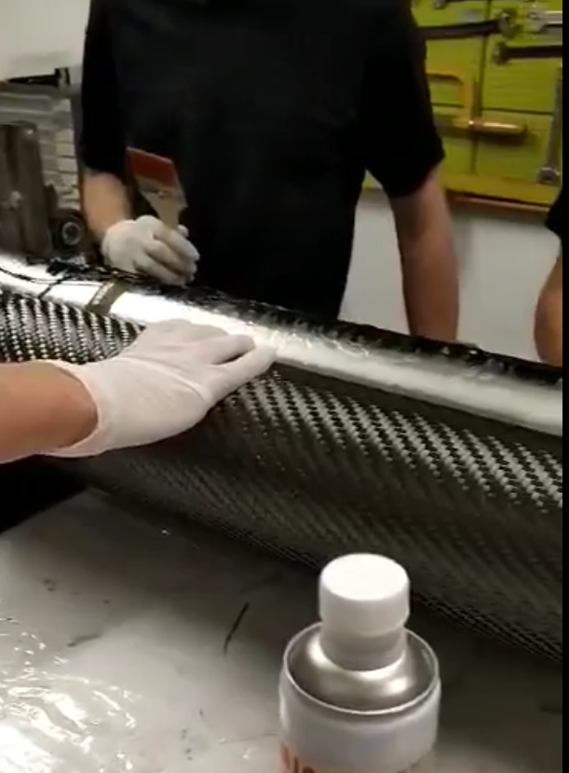

Figure .1 Old Winding technology for composite casing

## Motivation

In order to eliminate these problems and have a successful operations of the new engine after the production process such as hydrotests, assembling the entire engine before static tests and flights, as well as the need for direct winding, there was a need to develop a system that allows winding with the use of inserts with different design than their predecessor allowing us to gain ideal fitting between insulation and casing, without thed need to adjust the insulation to casing or move it in any way.

# 2. Solution

In order to achieve the objective of our system, we have to change the design of our system in a way which enables us direct winding on the insulation with inserts on the core. Hence the proposal to use a simillar core tube but with slightly different parameters with two fixed Lids of diameter 102mm (inner diameter of the body), as well as fixing the position of insulation with inserts on the core. The advantages of this option are: The new system is insusceptible to variations of the outer diameter of the insulation and allows us to fit perfectly for it’s length, resistant to water absorption during hydro tests due to no need of moving the insulation inside casing, constant Winding of the fabric with the need of only two single fiber wounds on both ends instead of four, while the disadvantages: Assembling the system will be slightly more difficult than the provious system, which makes the system slightly more complicated and thus more expensive.

# System Description

Elements of the new system for the production of the TuCAN class engine are: Coretube(shaft), 2x Lid M20, 2x support fix holder, 2x support plate, pressure tube, Module rings, Brass ring, 8x M10 screws, 4x M20 screws, 16x M8 screws. 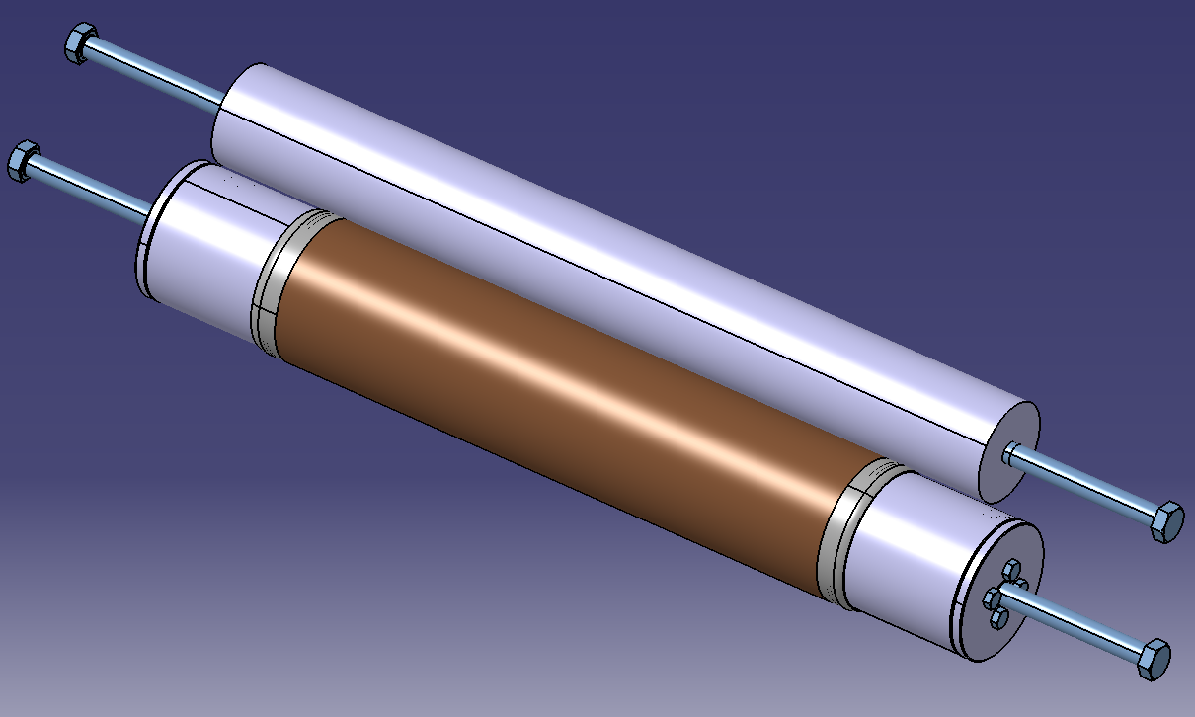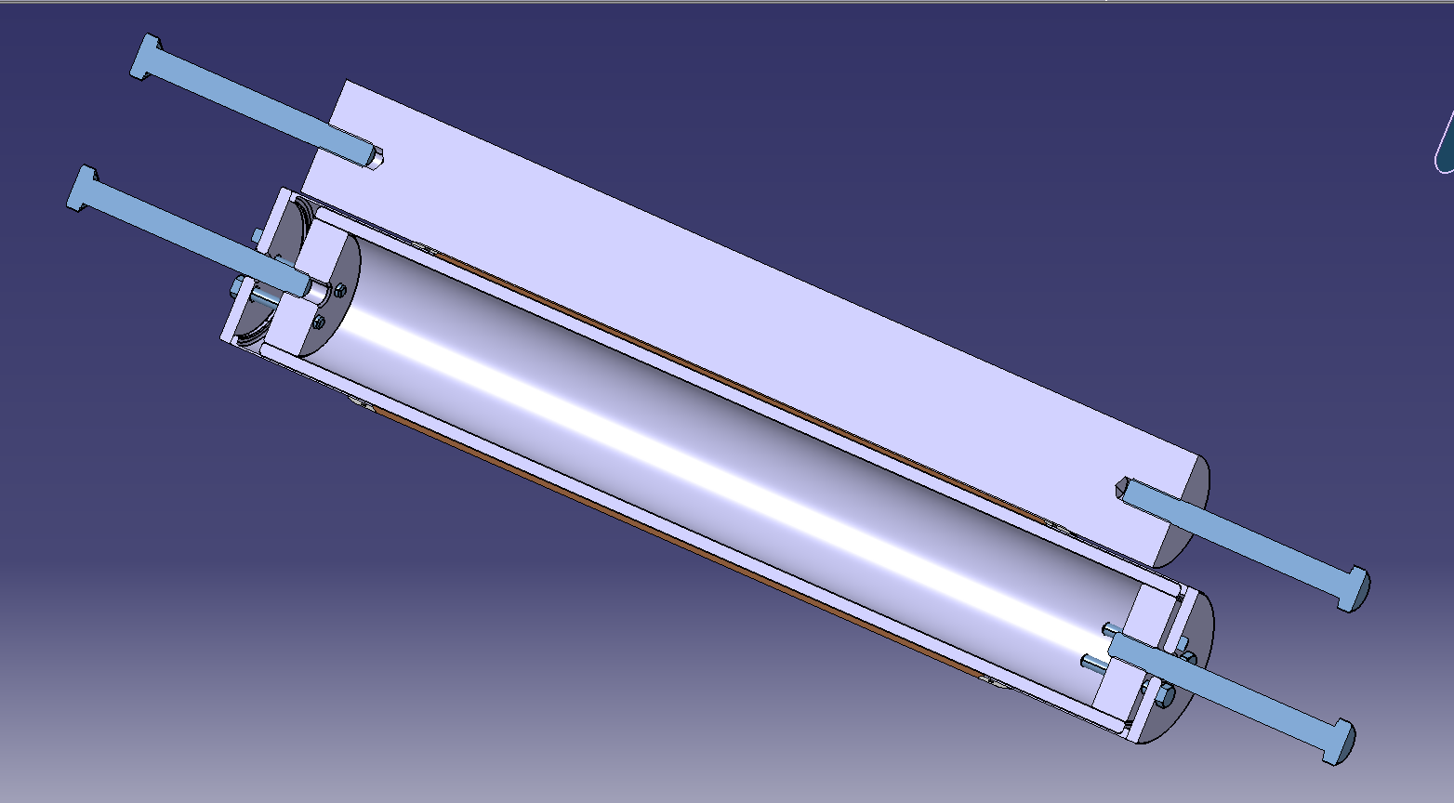

## Core Tube(NWST.1.00.00.001_core_tube)

The Core tube acts as the roller shaft of the entire system, it ensures stability, keeps all the other parts in place as well as enabling a smooth and proper winding of the fabric. The contact between the the shaft and the resin is very minimal thanks to the fact the laminate has no direct touch to the shaft, our shaft is made from Stainless steel which ensures chemical and mechanical strength and it is relatively easy to work with.

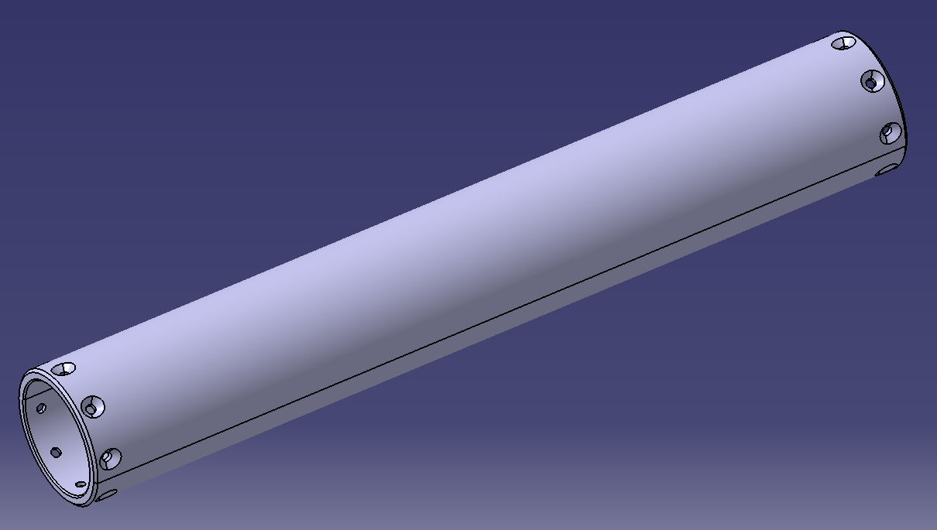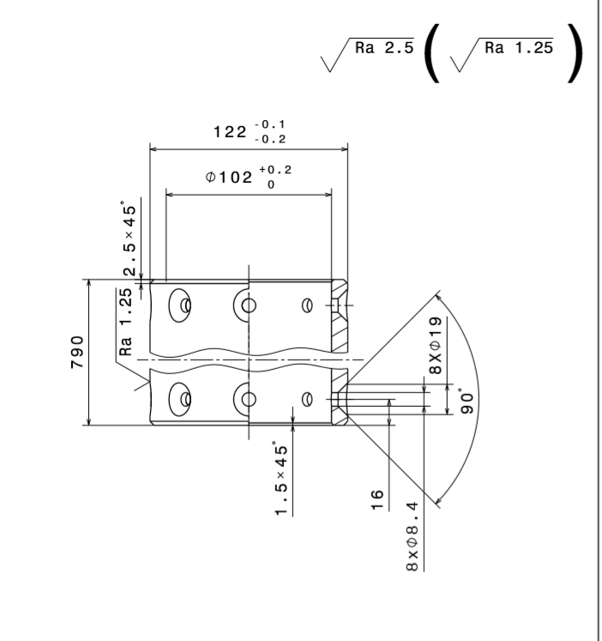

## Fix support holder (NWST.1.00.00.003_Support_fix_holder)

Fix support holder’s objective is to keep a steady grip of the insulation using the force produced by the M10 screws connecting the support plate with the M20 Lid.

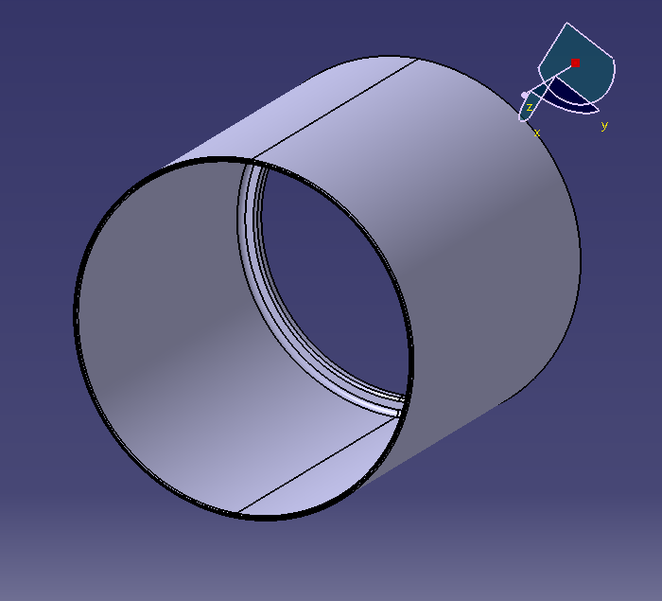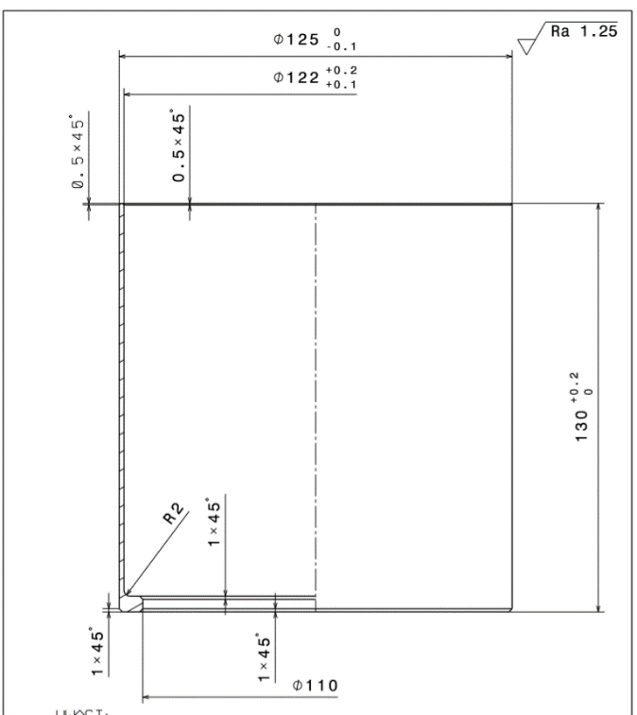

## Support plate (NWST.1.00.00.004_Support_plate)

The design of the support plate allows us to pin the support fix holder by connecting it with the M20 Lid using the M10 screws.

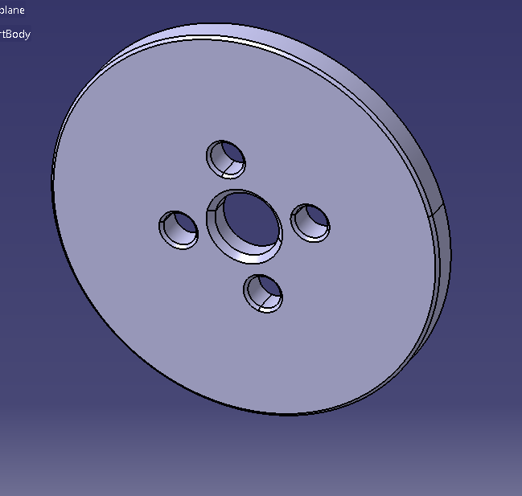

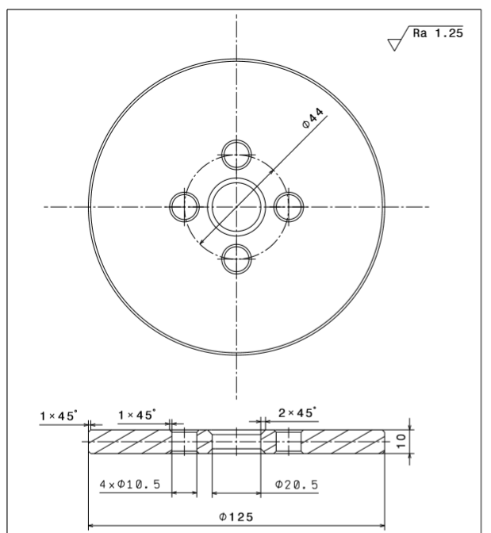

## 3.4 Brass ring (NWST.1.02.00.001_Brass_ring)

Another part of our dismantling support will be the brass ring which is also designed in a way that the outer diameter is greater than the SR puller which allows us easy extraction of the engine.

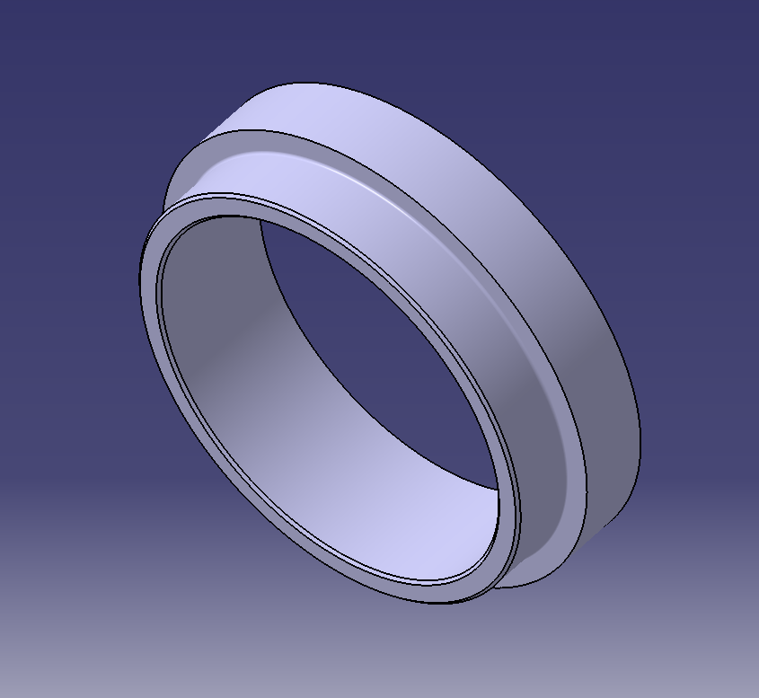

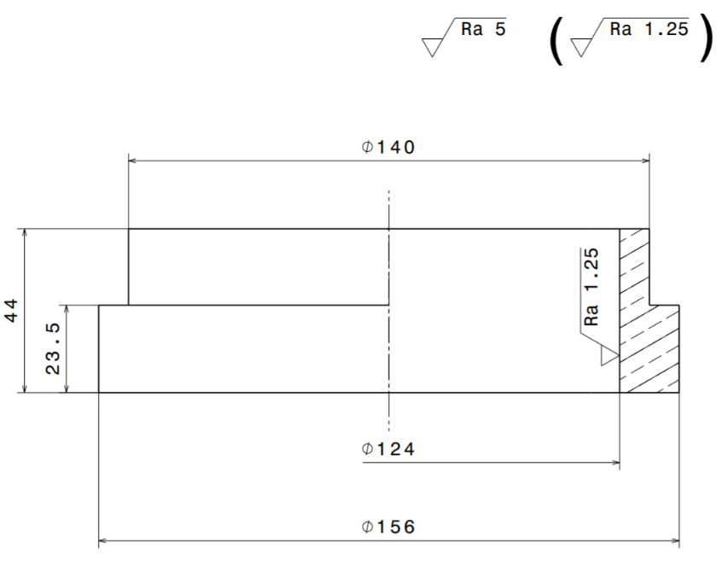

## Pressure exerting subsystem

Our pressure subsystem consists of one main tube, due to the fact that we have just one tube in our subsystem, the consequences will be a heavier subsystem, we chose the material to be stainless steel due to it’s chemical and mechanical strength, lastly we will have two module rings to keep the entire system in contact with our core tube(main shaft).

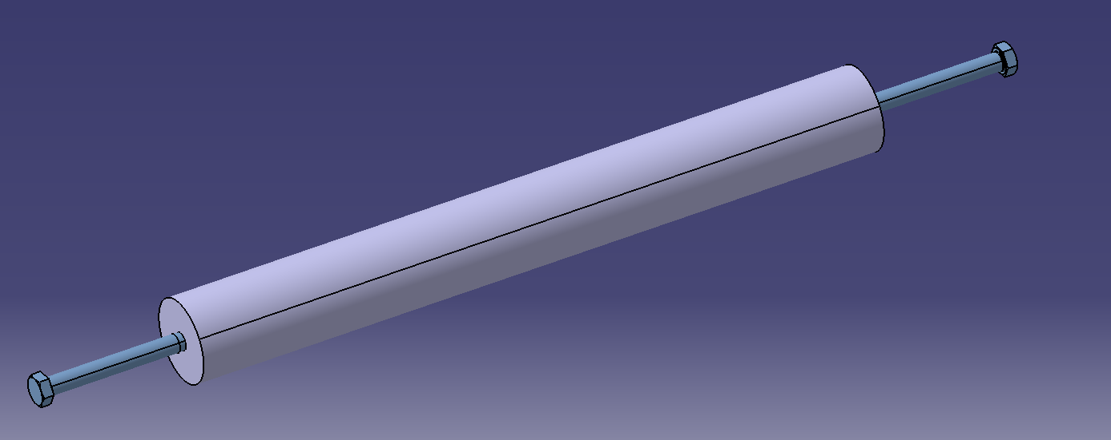

# 4 New engine production process – instruction

## 4.1 Introduction

Before reading the following instructions, it is recommended to read: Instructions for making composite engine bodies TuCAN, because it is based on this document and presents changes in comparison with the old process rather than a full-fledged instructions for making the engine with new technology.

Note: Before starting the production procedure make sure every part is cleaned with Acyton, Wear disposable gloves for your protection and in order not to damage the composite fabric.

## 4.2 Instructions

1. Start with with closing the shaft (core tube) using the M20 lids, apply the M8 scres to do so.

2. Insert the support fix holder directly to the core tube.

3. Place the support plate and make sure to allign the holes with the M10 holes on the M20

4. Insert the M10 screws through the support plate’s holes and the threaded holes on the M20 lid.

5. Mount the Core tube on the turning system by connecting the M20 screw into the end from the previous step, use some kind of support piece for the other end.

6. Apply first insert to the system.

7. Apply insulation to the shaft and then second insert.

8. Place the support fix holder into the other end and since we dont have any space left between the support fix holder and the core tube in the secured end this time the the support fix holder will naturally have atleast 20mm of space between it and the core tube which is necessary.

9. Place the support plate and once again allign the holes with the M20 lid holes.

10. Use the M10 screws to secure this end in the same way we used for the other end.

11. Secure it by using the M20 screw.

12. Check if the system is stable and safe.

13. Clean the assembled system once again, butter the places which the resin will come into contact with using moldsealer or graphite powder.

14. Prepare the Carbon cloth should be prepared before taking out the elements of the system.

15. Prepare the pressure exerting subsystem, start by mounting the tube on the pressure system mounting device and insert the two module rings however keep in mind to leave enough space for the casing between them after that secure both ends using the M20 screws.

16. Now that your system which exerts pressure is ready do not activate it yet

17. Check if your system is stable by rotating the Shaft one more time before starting the operation.

18. start winding the fabric and applying the appropriate amount of resin.

19. After completing the first lap of the fabric on the shaft activate the system which exerts pressure on your main system.

20. Upon completing the winding process, deactivate your pressure exerting system.

21. Start putting the rowing on both sides.

22. Transfer the rest of the system to the oven system.

23. Remove the system from the oven, prepare the SR puller.

24. Place the brass ring in the SR puller with the smaller diameter facing the puller.

25. Unscrew both support plates and remove them.

26. Mount the system with the puller using the M20 screw.

27. Gently start pulling the entire system with the puller.

28. Observe as the newly produced engine starts to push the other end’s support fix holder while the core tube is moving towards the puller’s direction, make sure everything is running smoothly.

29. The fixing element connected to the puller’s screw should desconnect from the newly produced engine but still in contact with the core tube

30. Take off the core pipe from the puller.

31. Now we have only our new engine connected with the other support fix holder

32. change the side and connect the puller’s screw to the support fix holder while the brass ring remains in the previous location

33. Gently start pulling again as you observe the disconnection between the support fix holder and the new engine.

34. Extract the engine and take it back to the workshop for assessment.

35. In case any form of extra composite is on the ends, use surface finishing to remove the excess.

36. Clean everything and put everything back in the previous location before starting the operation.

37. Make sure the workshop is clean after finishing the operation.

# 5 Summary

The new technology for the production of TuCAN engines presented in this document represents the development of engine production in the SKA Rocket Section and is constantly improving, therefore we will keep expermenting with new systems to ensure advancement of future technologies. In the positive case, this technology will be developed and applied to make better, more reliable engines for high altitude applications as this is our main purpose and we are looking forward to test it and develope some details in the future.